Incident Report Form

INSTRUCTIONS – To be completed by the worker, supervisor or manager at the time.

PART A: INCIDENT DETAILS
Name of person completing Incident Report:
Date of Incident: | Time of Incident: ☐ am ☐pm
Class of Incident:  ☐ Class 1: Death, Permanent Disability  ☐ Class 2: Temporary Disability, Medical /Hospital Treatment, Lost Time Injury (LTI)  ☐ Class 3: Notifiable incident to SafeWork NSW or NDIS (Serious injury of person with a disability, Medication error, Abuse or neglect of a person with a disability, Unlawful sexual or physical contact with or assault of a person with a disability, Sexual misconduct, Use of restrictive practice)  ☐ Class 4: Minor Injury, First Aid Injury, Property Damage, Motor vehicle accident, Physical / Verbal abuse, Psychological  ☐ Class 5: Near Miss / No immediate injury / Behaviour  ☐ Class 6: Allegation | Type of Incident:  ☐ Personal injury  ☐ Physical / verbal aggression  ☐ Dangerous incident  ☐ Behavioural (including absconding, neglect, sexual contact)  ☐ Medication error / Missed medication  ☐ Motor vehicle  ☐ Property damage  ☐ Notifiable incident to SafeWork NSW or NDIS  ☐ Near Miss (no immediate injury)  ☐ Allegation
Address / Location of Incident:

Details of Person/s involved:

Name: Phone Number:
☐ Participant ☐ Support Worker ☐ Other staff ☐ Member of Public

Name: Phone Number:
☐ Participant ☐ Support Worker ☐ Other staff ☐ Member of Public

For an Allegation - Details of Person/s making the record of alleged incident:

Name: Phone Number:
Witnesses or Other Support Workers on shift (If Applicable):

Name: Phone Number:
Location:
☐ Public venue ☐ Office ☐ Kitchen ☐ Participant home
☐ Car park ☐ Toilet/change room ☐ Other (Please Specify)
Experience in Job: ☐ 0 to 6 months ☐ 6 months to 1 year ☐ 1 year to 5 years
☐ 5 years and over ☐ Not applicable

Details of how incident occurred: (Attach additional pages and photographs as required)

PART B: INJURY DETAILS
Part of body or face injured: (Please mark below with a circle or cross)
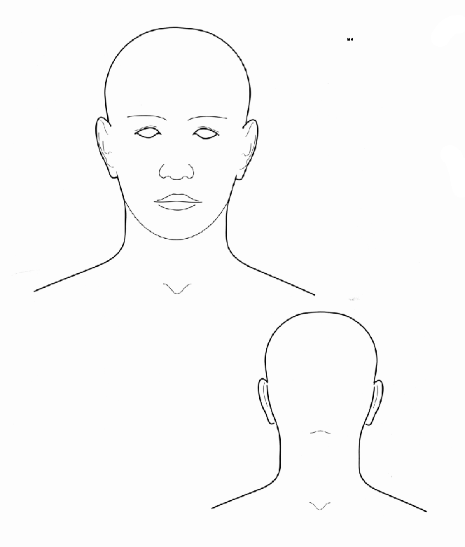
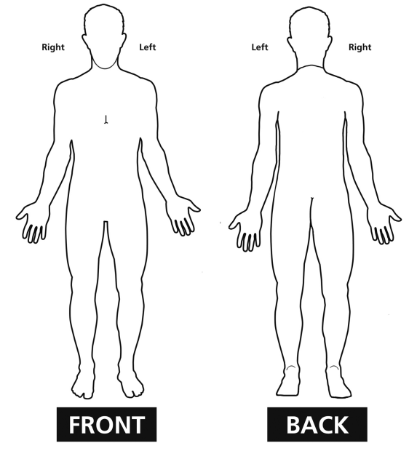
Nature of Injury or Disease: (Please mark all as required)
☐ Nil injury  ☐ Minor injury requiring no first aid  ☐ Intracranial injury (e.g. brain injury)  ☐ Fracture  ☐ Wound, lacerations, amputations, and internal organ damage (includes needle-stick puncture, contusion, bruising and superficial crushing) | ☐ Burn (electrical, chemical, cold, hot, friction, combination)  ☐ Injuries to nerves and spinal cord  ☐ Traumatic joint / ligament and muscle / tendon injury  ☐ Other injuries (foreign body, poisoning, electric shock, heat stress, effects of weather, anaphylaxis,  ☐ Multiple injuries
☐ Nil disease  ☐ Musculoskeletal and connective tissue diseases  ☐ Mental diseases  ☐ Digestive system diseases  ☐ Skin and Subcutaneous tissue diseases | ☐ Respiratory system diseases  ☐ Circulatory system diseases  ☐ Infectious and parasitic diseases  ☐ Cancer  ☐ Other diseases
Mechanism of Injury: (Please mark all as required)
☐ Falls, trips and slips of a person  ☐ Being hit by moving objects or person  ☐ Body stressing  ☐ Chemical and other substances  ☐ Other and unspecified mechanisms of incident | ☐ Hitting objects with a part of the body  ☐ Sound and pressure  ☐ Heat, electricity and other environmental factors  ☐ Mental stress  ☐ Unknown or Nil

PART C: RECORD OF TREATMENT
Nature of Treatment: (Please mark all as required)
☐ First Aid ☐ Medical Treatment – Doctor ☐ Medical Treatment – Hospital ☐ Medical Treatment – Ambulance
☐ Other:
Comments:
Name of First Aid Officer: Signature: Date:

PART D: RETURN TO WORK COORDINATOR (if required)
Return to Work Coordinator Contacted: ☐ Yes ☐ No ☐ Not Applicable
Name of RTW Coordinator: Signature: Date:
Lost Time Injury: ☐ Yes ☐ No If Yes, provide Claim Number:

PART E: MANAGER REVIEW
Management Comments:
Name: Signature: Date:

Please send completed form to your manager for review prior to end of shift.

PART F: INCIDENT RECORDING
This incident Report has been recorded in the Incident Register.
☐ Yes ☐ To be completed ☐ No – Reason:
Name: Signature: Date:

